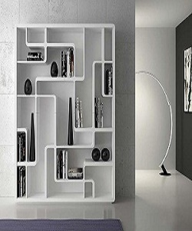

Modern Bookcase

$91.50

Availability: In stock

**Description:**

Modern white wall bookcase with many sections. The real modular extruded wood bookcase,a special way to personalize your space.It's a system that can be used everywhere: in office, in living room,and in a book store of a winebar.This furniture is usable for every need.